Masters of Computer and Information Sciences

ASSIGNMENT COVER SHEET - INDIVIDUAL
Student Name and ID: LI, Mao Chuan; 14854389
Date: 2015/03/13
Paper Name and Code: Software Requirements Engineering, 409220
Assignment Name: Research Paper Analysis | Number of Words/Pages: 1600/6

In order to ensure fair and honest assessment results for all students, it is a requirement that the work that you hand in for assessments is your own work.

Please read and place an “X” in the boxes below to confirm that the statements are true of the work you are submitting.

Where I have used someone else’s words, I have indicated this (using quotation marks and adding the reference). Where I have used other people’s ideas or writing, I have indicated this by putting them into my own words and adding the reference. |  |  | X
Other than this, this assignment:
IS NOT copied from another student or from a previous assignment. |  | X
IS NOT copied from books, journals, Web pages or other sources. |  | X
HAS NOT been handed in by me or anyone else in any other course. |  | X
IS WRITTEN BY ME as the sole author |  | X
 | Complete this section only if the assessment is being submitted after the original assessment deadline
 | Extension granted? YES / NO
If an extension was granted, by whom: .........................…………………(name),

and until when: ..................... (date & time)

By filling out the form and submitting it electronically I confirm that it is a true and accurate statement about me, the named student.

Application Area 1 – CarEvaluation
- Using the J48 Decision Tree with all parameters set at default values. From the model generated rank the 3 most important features. safety, persons, buying

- Alter one of the J48 parameters and obtain an overall classification value that is at least 96%.

- Which parameter did you adjust?
binarySplits
- Why did the new setting of this parameter improve accuracy?
With this change, the tree became smaller
Number of Leaves : 131, Size of the tree : 182
Number of Leaves : 69, Size of the tree : 137

- Do you expect that manipulating the parameter in the same way will improve accuracy for other types of datasets? Justify your answer.
No, normally using 'binarySplits' will increase the size of decision tree. In this dataset, all attributes are nominal, so it fits better.

- It is possible to reduce the number of decision paths to 30 whilst ensuring that accuracy is over 95%.
  - Which parameter achieves this result?
ReducedErrorPruning

  - What is the role of this parameter? (do not simply use Weka’s description here; do your own research and
The role of the parameter is to control the J48 algorithm if it should post-prune the tree to make it smaller while keeping a reasonable accuracy of the decision tree. In this case, turning on this feature achieved a smaller tree with only 30 leaves while maitaining a high accuracy of 95.8333 %.

- It is possible to reduce the number of decision paths further to 20 while ensuring that accuracy is around the 91% mark.
  - Which parameter (different from the one identified in c) above) is responsible for this?
MinNumObj

  - What is the role of this parameter?
This is a parameter to control the minimal instance number in a tree leaf. I set the parameter with 10. The bigger the minNumObj is, the smaller the tree will be.

- Examine the Confusion Matrix carefully. You will notice that the success rate of predictions for the “good” and “vgood” classes for the model produced in d) above is much lesser than for the other two classes.
  - Why do you think this happens?
The main reason here is that the training data set is imbalanced. Only 65/1728 = 3.76% for vgood class, and 69/1728=3.99% for good class.
  - Use cost sensitive classification with the J48 algorithm and all parameter settings as used in d) above to produce a model that has at least 90% success rate on all 4 classes. Give the cost sensitive matrix that achieves this result.
Cost Matrix
0 1 1 2
1 0 1 5
1 2 0 15
1 6 30 0
TP Rate FP Rate Precision Recall F-Measure ROC Area Class
0.936 0.014 0.994 0.936 0.964 0.982 unacc
0.911 0.059 0.816 0.911 0.861 0.96 acc
0.923 0.008 0.822 0.923 0.87 0.996 vgood
0.913 0.014 0.724 0.913 0.808 0.951 good

Application Area 2 – Diabetes
- As with dataset 1, use an appropriate method of feature selection to identify the most significant features. State method used and list the features produced.
Search Method: weka.attributeSelection.LinearForwardSelection -D 0 -N 5 -I -K 50 -T 0
Selected attributes: plas, mass, pedi, age

- Run the Naïve Bayes algorithm with the UseSupervisedDiscretion option set to “True”. Use the count table produced by the Naïve Bayes model to produce a probability model table similar to the one discussed in class. Use this probability table to identify the top 3 (feature, value) pairs that predict the presence of heart disease. Show all working.
The top 3 feature value pairs are:
mass = '(27.85-inf)'
age = '(28.5-inf)'
preg = '(-inf-6.5]

The following is the probability table:
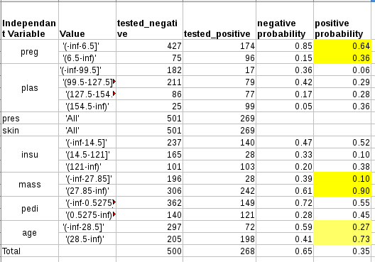
- Now run the J48 algorithm and compare the list produced in 1 above with the top 3 features produced by the J48 Decision tree model. Identify similarities and differences. Discuss any differences. [5 marks]

The top 4 features in step 1 are:
plas, mass, pedi, age
The top 3 features produced by the J48 Decision tree are:
plas, mass, age

